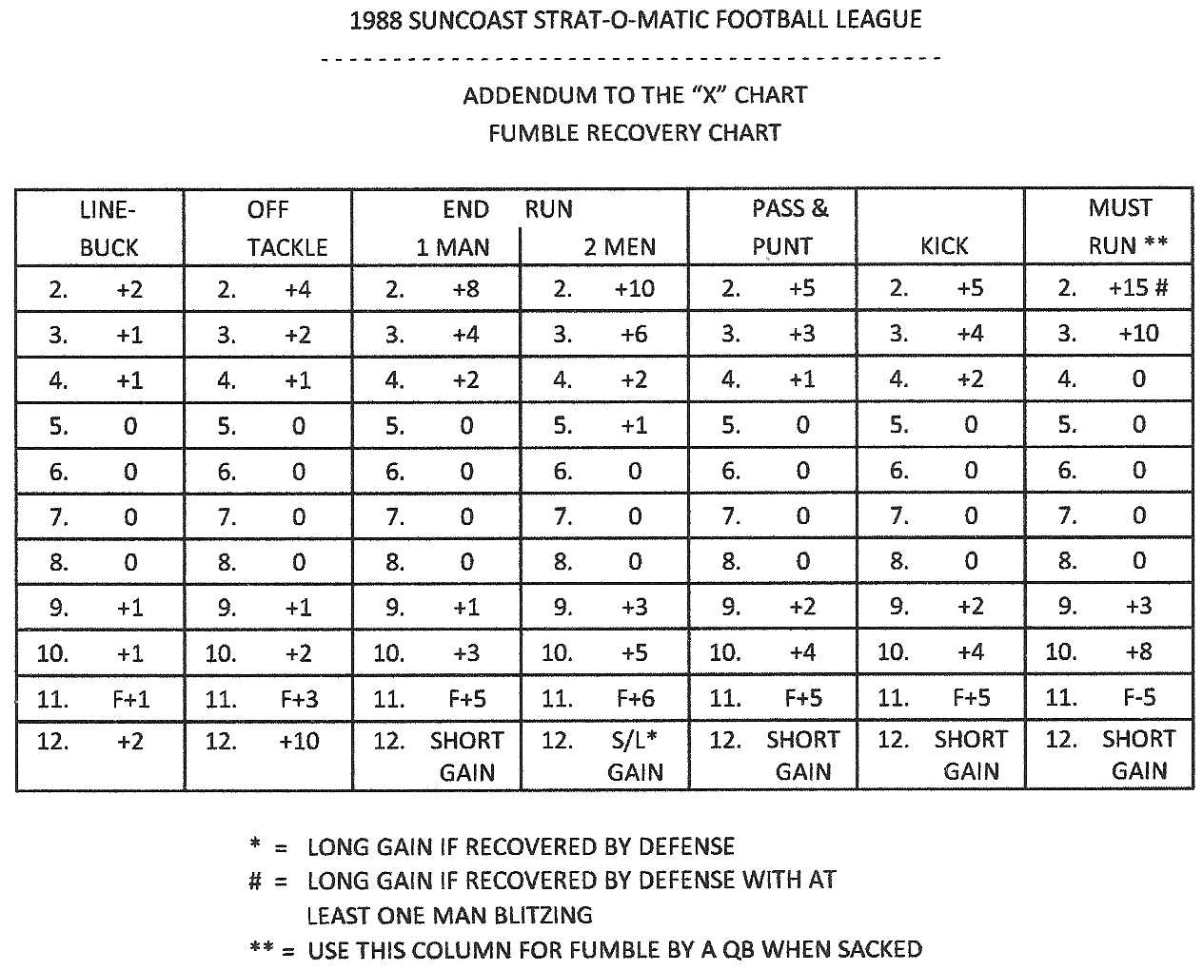

 | PASS | BLOCK |  |  | PASS | RUSH |  |  | QB |  |  | INJURY
 | 3 - 4 | 4 - 3 |  |  | 3 - 4 | 4 - 3 |  |  | SACKS |  |  | DURATION |  |  | PUNT | BOUNCE
1. | ORT | ORT |  | 1. | DLE | DLE |  | 2. | -13 |  | 2. | 3 GMS |  | 2. | FORWARD 20 YDS
2. | ORG | ORG |  | 2. | 2 HLB | DLT |  | 3. | F-12 |  | 3. | 2 GMS |  | 3. | ROLL FOR RETURN
3. | OC | OLG |  | 3. | DNT | DRT |  | 4. | -11 |  | 4. | 1 GM |  | 4. | FORWARD 12 YDS
4. | OLG | OLT |  | 4. | HLB | DRE |  | 5. | -10 |  | 5. | DUR |  | 5. | FORWARD 5 YDS
5. | OLT | OC |  | 5. | DRE | HLB |  | 6. | -9 |  | 6. | 2 QTRS |  | 6. | FORWARD 10 YDS
6. | BB | BB |  | 6. | * | * |  | 7. | -8 |  | 7. | 1 QTR |  | 7. | FORWARD 13 YDS
 |  |  |  |  |  |  |  | 8. | -7 |  | 8. | 2 QTRS |  | 8. | BACKWARDS 3 YDS
 |  |  |  |  |  |  |  | 9. | -6 |  | 9. | DUR |  | 9. | 0 YDS (DEAD BALL)
 |  |  |  |  |  |  |  | 10. | -5 |  | 10. | 1 GM |  | 10. | FORWARD 9 YDS
 |  |  |  |  |  |  |  | 11. | -4 |  | 11. | 2 GMS |  | 11. | ROLL FOR RETURN
 |  |  |  |  |  |  |  | 12. | -3 |  | 12. | 3 GMS |  | 12. | BACKWARDS 10 YDS

