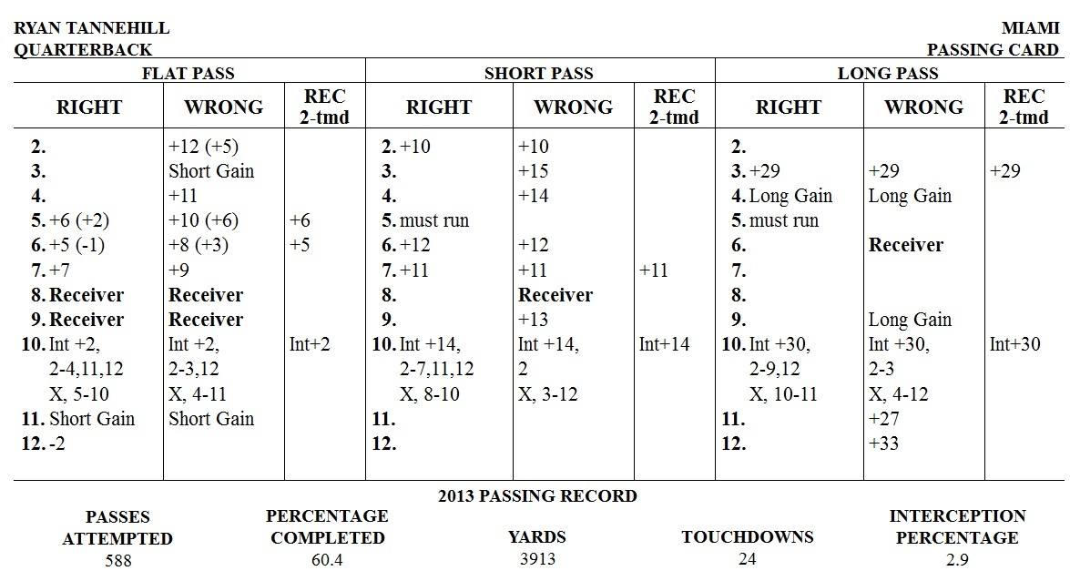
YARDS AFTER CATCH – OPTIONAL RULE

For some seasons produced after 2014, there are double readings (readings in parentheses) found in the Quarterback Flat Pass columns (see 2013 Ryan Tannehill card below). When not using this optional rule, ignore the reading in parenthesis and use the original result. When using this optional rule, the reading in parentheses indicates how many yards the pass travels in the air before it is caught. To determine how many yards the receiver added after making the catch, roll 2 dice and refer to the YARDS AFTER CATCH CHART using the receiver’s YAC rating. Add the yards gained (or lost) to the reading found in parenthesis on the quarterback card to determine the total yards for the completion. For example, using the 2013 Tannehill card below, if you roll a 5 on Flat Pass Right with a receiver that has a ‘B’ YAC rating, you would start with a +2 completion and then roll two dice and refer to the Yards After Catch Chart. If the second dice roll is a 4, the receiver would gain an additional 11 yards on top of the original 2 yards, for a 13-yard completion. If you are not using the Yards After Catch rule, ignore the second reading in parentheses and use the first number, which in this case, would make the play a 6-yard completion.

Notes:
• When a reading of “LG” is found on the YARDS AFTER CATCH CHART, do not add the Long Gain chart result to the number in parenthesis on the QB card. Instead, roll the dice on the Long Gain chart and use whatever reading that is found there as the final result of the play.
• Remember that receivers should not exceed their longest gain, if using that rule.

YARDS AFTER CATCH CHART

 | Receiver’s YAC Rating
ROLL | A | B | C | D | E
2 | LG | LG | 23 | 21 | 15
3 | 20 | 14 | 13 | 11 | 10
4 | 14 | 11 | 10 | 8 | 6
5 | 11 | 10 | 7 | 2 | 0
6 | 0 | 0 | 0 | 0 | 0
7 | -1 | -1 | -1 | -1 | -1
8 | 6 | 2 | 0 | 0 | -1
9 | 10 | 8 | 6 | 4 | 2
10 | 17 | 12 | 11 | 9 | 8
11 | 22 | 16 | 13 | 12 | 11
12 | LG | 24 | 20 | 16 | 12

